3322
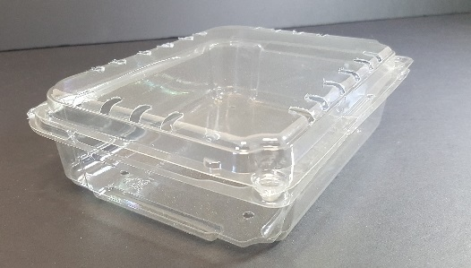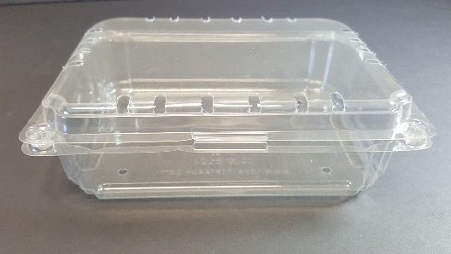

Item Number: 3322
Item Description: 14oz Campari Tomato Clamshell

Product Dimension (W x L x H): 7.25 x 11.26 x 2.10

Product Weight: 27g +/-2g

Total Pieces / Case: 600

Case Dimension: 23" x 19 ½" x 15"

Total Cases per pallet: 24 (4 cases x 6 layers)

