Description: 1lb 4DN Cherry Topseal Tray
Item number: RPTS2015
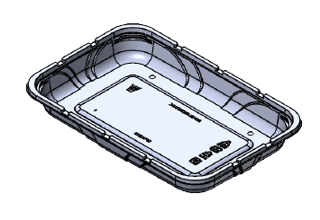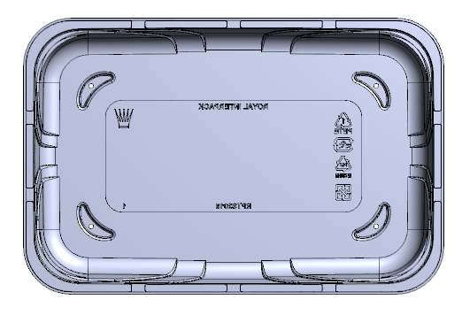

Product Information

Product Dimension in (L x W x H): 11.02 x 7.24 x 1.412
Product Gram Weight: 38g (+/- 2g)
Color: Clear Material: RPET
Shape: Rectangular
Product Type: Topseal
Case Dimension (in inches): 19.5 x 14.875 x 22.187
Case Pack: 256 pcs
Case Net Weight (in lbs.): 22 avg.
Cases Per Pallet: 24
Pallet Pattern (TI x HI): 4 x 6
Pallet Weight (lbs.): 568

