Description: 2lb Cherry 4dn Topseal Tray
Item number: RPTS2019
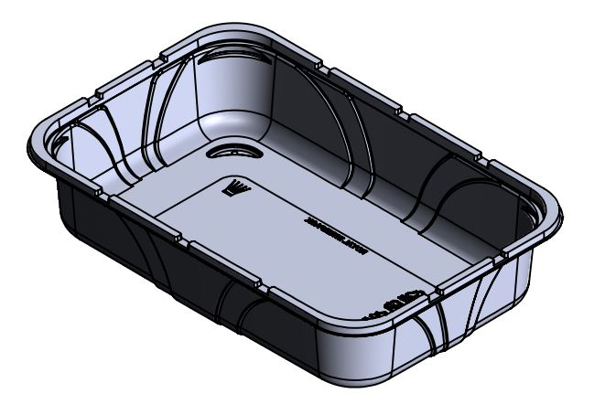

Product Information

Product Dimension in (L x W x H): 11.02 x 7.24 x 2.45
Product Gram Weight: 49g (+/- 2g)
Color: Clear Material: RPET
Shape: Rectangular
Product Type: Topseal
Case Dimension (in inches): 22.187 x 19.5 x 14.875
Case Pack: 248pcs
Case Net Weight (in lbs.): 26.62
Cases Per Pallet: 24
Pallet Pattern (TI x HI): 4 x 6
Pallet Weight (lbs.): 674

