Description: 3lb Cherry (4DN) Topseal Tray
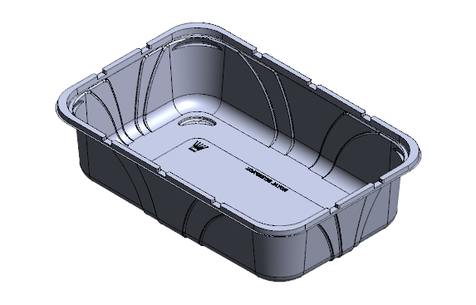
Item number: RPTS2020

Product Information

Product Dimension inches (L x W x H): 11.02 x 7.24 x 2.87
Product Gram Weight: 41.7g (+/- 2g)
Color: Clear Material: RPET
Shape Rectangular
Product Type: Topseal
Case Dimension (in inches): 22.187 x 19.5 x 14.875
Case Pack: 240pcs
Case Net Weight (in lbs.): 25.75
Cases Per Pallet: 24
Pallet Pattern (TI x HI): 4 x 6
Pallet Weight (lbs.) 655

