Description: 18oz Blueberry Topseal Tray
Item number: RPTS2033

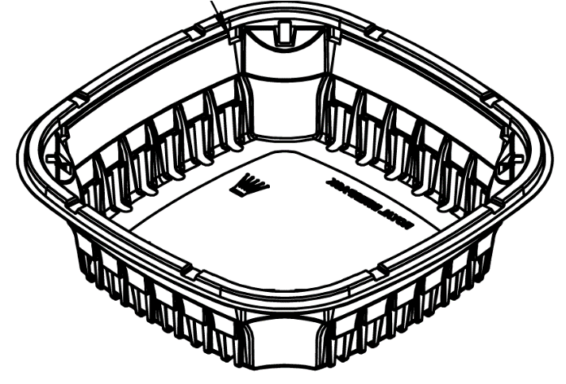

Product Information

Product Dimension inches (L x W x H): 7.520 x 7.520 x 2.050
Product Gram Weight: 30g (+/- 2g)
Color: Clear Material: RPET
Shape Rectangular
Product Type: Topseal
Case Dimension (in inches): 23.125 x 15.5 x 18
Case Pack: 480pcs
Case Net Weight (in lbs.): 27
Cases Per Pallet: 20
Pallet Pattern (TI x HI): 5 x 4
Pallet Weight (lbs.) 620

