Description: 2lb 8DN Cherry Topseal Tray
Item number: RPTS2019

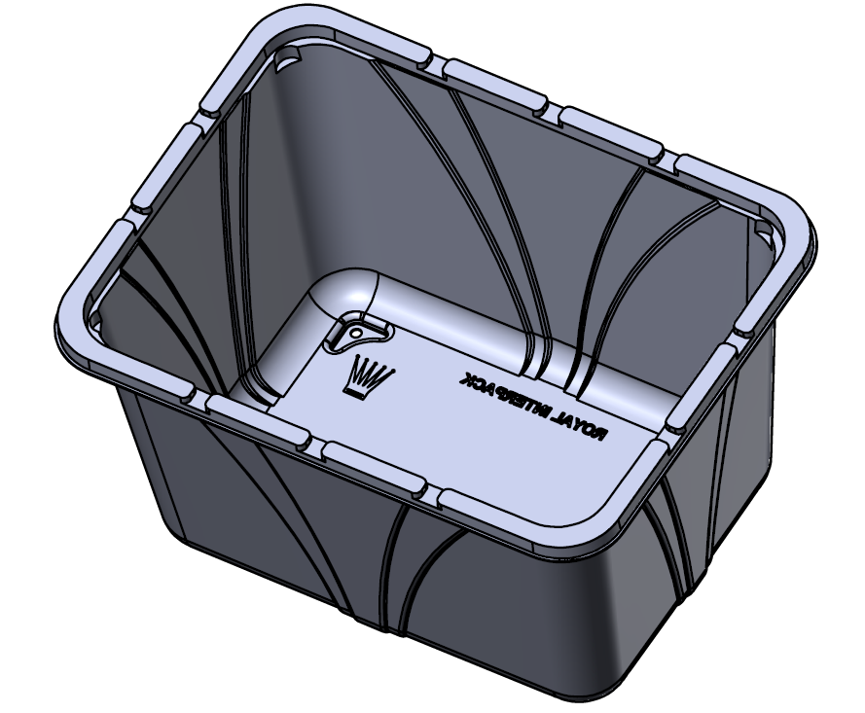

Product Information

Product Dimension in (L x W x H): 7.20 x 5.50 x 4.2
Product Gram Weight: 27 (+/- 2g)
Color: Clear Material: RPET
Shape: Rectangular
Product Type: Topseal
Case Dimension (in inches): 24 x 18.5 x 14.375
Case Pack: 552 pcs
Case Net Weight (in lbs.): 34lbs
Cases Per Pallet: 20
Pallet Pattern (TI x HI): 4 x 5
Pallet Weight (lbs.): 720

